|  |
| --- |
| **Asteroid Mining**  John Fogarty  Ken Litfin  Amanda Litfin  Houston Russell  Sam Woo  Manish Chaudhary |

# **Introduction**

With the advent of technology and the expanding future of space exploration, asteroid mining is becoming more feasible. There are already some components in space, or in the planning stages that will soon be implemented, which will allow asteroid mining to be more cost effective.

**Why Mine Asteroids?**

Asteroids could one day be a vast new source of scarce material if the financial and technological obstacles can be overcome. Asteroids are lumps of metals, rock, and dust, sometimes laced with ices and tar, which are the cosmic "leftovers" from the solar system's formation about 4.5 billion years ago. There are hundreds of thousands of them, ranging in size from a few yards to hundreds of miles across. Small asteroids are much more numerous than large ones, but even a little, house-sized asteroid should contain metals possibly worth millions of dollars.

There are different kinds of asteroids, and they are grouped into three classes from their spectral type – a classification based on an analysis of the light reflected off of their surfaces. Dark, carbon-rich, "C-type" asteroids have high abundances of water bound up as hydrated clay minerals. Although these asteroids currently have little economic value since water is so abundant on Earth, they will be extremely important if we decide we want to expand the human presence throughout the solar system.

"Water is a critical life-support item for a spacefaring civilization, and it takes a lot of energy to launch it into space," says Dante Lauretta of the University of Arizona, Tucson, principal investigator for NASA’s OSIRIS-REx asteroid sample return mission. "With launch costs currently thousands of dollars per pound, you want to use water already available in space to reduce mission costs. The other thing you can do with water is break it apart into its constituent hydrogen and oxygen, and that becomes rocket fuel, so you could have fuel depots out there where you're mining these asteroids. The other thing C-type asteroids have is organic material – they have a lot of organic carbon, phosphorous and other key elements for fertilizer to grow your food," said Lauretta.

Somewhat brighter asteroids have a stony composition. These "S-type" asteroids have very little water but are currently more economically relevant since they contain a significant fraction of metal, mostly iron, nickel and cobalt.

"However, there are a fair amount of trace elements that are economically valuable like gold, platinum and rhodium," said Lauretta. "A small, 10-meter (yard) S-type asteroid contains about 1,433,000 pounds (650,000 kg) of metal, with about 110 pounds (50 kg) in the form of rare metals like platinum and gold," said Lauretta.

There are rare asteroids with about ten times more metal in them, the metallic or "M-class" asteroids, according to Lauretta.

However, it currently costs hundreds of millions to billions of dollars to build and launch a space mission, so innovations that would make these costs fall dramatically are needed before it is profitable to mine asteroids for the value of their metals alone.

Another obstacle is simply our lack of experience with mapping and analyzing the resources in asteroids to extract material from them. This critical experience will be gained with NASA's asteroid sample return mission, OSIRIS-REx (Origins, Spectral Interpretation, Resource Identification, Security and Regolith Explorer).

(http://www.nasa.gov/content/goddard/new-nasa-mission-to-help-us-learn-how-to-mine-asteroids)

**Asteroid Composition**

Iron meteorites

* + Iron: 91 percent
  + Nickel: 8.5 percent
  + Cobalt: 0.6 percent

Stony meteorites

* + Oxygen: 36 percent
  + Iron: 26 percent
  + Silicon: 18 percent
  + Magnesium: 14 percent
  + Aluminum: 1.5 percent
  + Nickel: 1.4 percent
  + Calcium: 1.3 percent

(http://www.space.com/51-asteroids-formation-discovery-and-exploration.html)

Asteroids are small, dark, and easily obscured by the distorting effect of Earth's atmosphere. The best way to hunt for them is with a telescope floating in space. Since Planetary Resources already has a working model, for the purpose of this challenge, we are using the assumption that this will be available.

The best way to hunt for them is with a telescope floating in space. At the Bellevue, Wash., headquarters of Planetary Resources, chief engineer and company president Chris Lewicki is assembling the components of the first privately owned space telescope, the Arkyd 100 series.

The 44-pound spacecraft will be smaller and simpler than any government-funded space telescope. The $1.5 billion Hubble Space Telescope has a 94-inch-diameter primary mirror; Arkyd's mirrors will be 9 inches wide. Hubble has a wide field of view, as well as other instruments to scan objects in distant space. Arkyd needs only to look in our own solar system for targets. Cost is always a factor. It’s expensive to send things into space. Using a small telescope that can ride as secondary payload decreases launch costs.

(http://www.popularmechanics.com/space/a7942/how-to-mine-an-asteroid-11644811/)

Once the company telescopes spot a mining prospect and stakes a claim, there's only one way to determine what resources the asteroid contains: Get close. That is where our project comes in.

**Let the Light Shine**

One of the first hurdles our team encountered was how to effectively determine the materials in an asteroid. It would be fruitless and expensive to waste time mining an asteroid if there were not resalable materials on it. Isaac Newton used a prism to split white light into a spectrum of color, and Fraunhofer's high-quality prisms allowed scientists to see dark lines of an unknown origin. It was not until the 1850s that Gustav Kirchhoff and Robert Bunsen would describe the phenomena behind these dark lines—hot solid objects produce light with a continuous spectrum, hot gasses emit light at specific wavelengths, and hot solid objects surrounded by cooler gasses will show a near-continuous spectrum with dark lines corresponding to the emission lines of the gasses. By comparing the absorption lines of the sun with emission spectra of known gasses, the chemical composition of asteroids can be determined (https://en.wikipedia.org/wiki/Astronomical_spectroscopy).

Human visible light wavelengths range from 380 [nm](https://en.wikipedia.org/wiki/Nanometre) to 760 nm



* https://en.wikipedia.org/wiki/Electromagnetic_spectrum#Visible_radiation_.[28light.29](https://en.wikipedia.org/wiki/Electromagnetic_spectrum%23Visible_radiation_.28light.29)
* http://www.midnightkite.com/color.html

**Problems with Using Light**

Light Signals are Noisy

* Measurements taken by cameras are inherently noisy.
  + For most images we don’t know how well the camera was calibrated
  + We don’t know the albedo (ratio of surface reflectance) for the asteroid.
  + High albedo surfaces will have lots of specular reflection meaning that they will tend to look dark if the reflected light is not at the same angle as the camera lens
  + We don’t know the albedo of the surface because we don’t know what the surface composition is but we’re trying to use light emissions to estimate surface composition.

Surface Light Can Be Affected by Other Physical Factors

* Asteroid surfaces have craters which appear darker
  + Cratered surfaces also have slightly different surface composition because the impact that produced the crater adds heat and pressure to the surface, which changes the chemical composition.
  + Objects impacting the asteroid surface also deposit foreign materials on the surface.

**Manning Mars**

Inhabiting Mars is already in the works. A fleet of robotic spacecraft and rovers already are on and around Mars, dramatically increasing our knowledge about the Red Planet and paving the way for future human explorers. The Mars Science Laboratory Curiosity rover measured radiation on the way to Mars and is sending back radiation data from the surface. This data will help us plan how to protect the astronauts who will explore Mars. Future missions like the Mars 2020 rover, seeking signs of past life, also will demonstrate new technologies that could help astronauts survive on Mars. (http://www.nasa.gov/content/nasas-journey-to-mars).

Once Mars is manned, engineers and scientists will send up the necessary equipment and manpower to make a mining base fully functional.

**Send in the Drone**

Once the determination is made of possible minable elements, our drone will direct the asteroid to Mars for a directed crash landing. Utilizing Mars gives the asteroid stability and flexibility to gather minerals from the asteroid. It will be on the ground, thus allowing for a variety of equipment to be used, as well as an area around it for multiple people to maneuver around.

Calculations will have to be preprogramed into the drone’s computer system before leaving Earth. Scientists and engineers will play a major role in this endeavor since the drone will be unmanned. The calculations will have to be precise.

The drone will have a primary and a secondary shot capability. If, for some reason, there is a failure of the primary harpoon (i.e. the first does not get a secure hold or it shears off), a secondary will be launched to ensure success.

The drone will come into close proximity of the asteroid. Once in position, the drone will fire a grappling hook into the asteroid’s surface. On the exposed end of the hook will be an ion propulsion unit that will propel the asteroid down to the designated area on Mars.

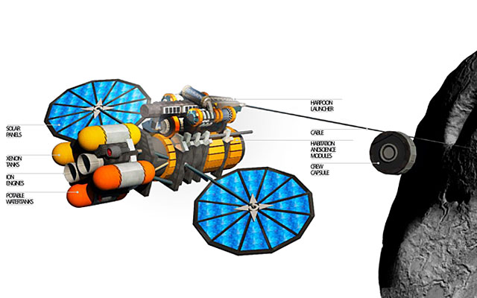

photo credit: http://www.popularmechanics.com/space/a6856/how-nasa-will-harpoon-an-asteroid/

Projectiles would need to be tailor-made for each target. "Some asteroids might have a metallic core, and trying to anchor to them would be like banging a nail into an anvil," says Jeffrey Hoffman, a professor of aeronautics and astronautics at MIT and a former astronaut. "Others may just be a rubble pile, which would be like trying to pitch a tent on a snowfield."

(http://www.popularmechanics.com/space/a6856/how-nasa-will-harpoon-an-asteroid/).

Once the hook is securely anchored in place, the ion propulsion unit will fire, sending it on its way down to Mars.

**The Asteroid Has Landed**

Once securely on the ground, it’s time for the ground crew to get started. Just like mining on the Moon, it will be the same principle on Mars.

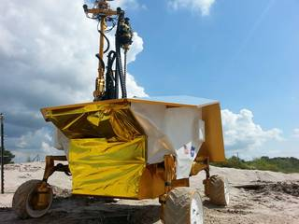

The Resource Prospector prototype searches for a buried sample tube at the Johnson Space Center rock yard in August 2015.

***Credits: NASA***

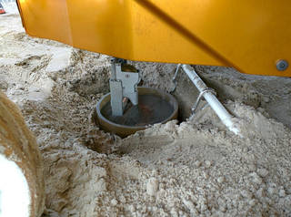

Resource Prospector begins to drill the sample.

***Credits: NASA***

**Conclusion**

Asteroid mining is becoming more feasible. There are already some components in space, or in the planning stages that will soon be implemented, which will allow asteroid mining to be more cost effective. We will be able to utilize the resources of space as we venture forth into the future.

**Resources**

http://www.popularmechanics.com/space/a6856/how-nasa-will-harpoon-an-asteroid/

http://www.nasa.gov/content/nasas-journey-to-mars

https://en.wikipedia.org/wiki/Electromagnetic_spectrum#Visible_radiation_.[28light.29](https://en.wikipedia.org/wiki/Electromagnetic_spectrum%23Visible_radiation_.28light.29)

http://www.midnightkite.com/color.html

https://en.wikipedia.org/wiki/Astronomical_spectroscopy

http://www.nasa.gov/content/goddard/new-nasa-mission-to-help-us-learn-how-to-mine-asteroids

(http://www.space.com/51-asteroids-formation-discovery-and-exploration.html)